1. **An E-R diagram representing the conceptual design of the database**

[**Phase 1 E-R Diagram**](https://www.lucidchart.com/invitations/accept/06e1d159-7cbc-492e-aa2c-301af3a8e749)

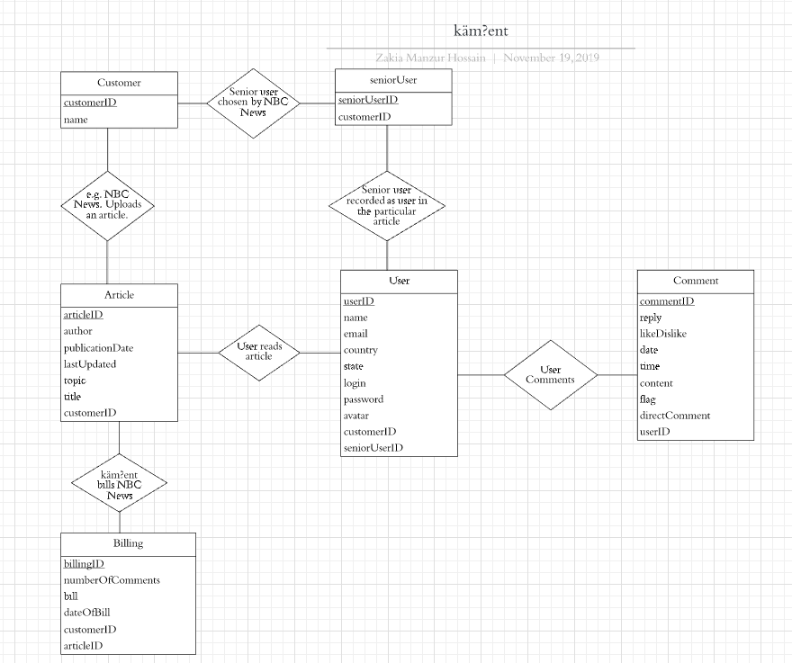

1. **Identify primary keys, relationship cardinalities, etc**

Primary keys:

* Customer: customerID
* Article (or Item/Artifact): articleID
* User: userID
* Comment: commentID
* Billing: billingID
* seniorUser: seniorUserID

Relation Cardinality:

* One-to-many: Customer to Article, Customer to Billing & Customer to User
* One-to-one: User to Article
* Many-to-many: Article to Comment

1. **Describe the challenges you met while implementing this phase of the project**

I think the biggest challenge was to identify all the entity relationships. Although I am given the entities, it was challenging to figure out how each entity related to each other. I am not certain about some of the keys in a few entities, for example I am not certain if `seniorUser` should be an entity or a key. For my E-R diagram above I added a `seniorUser` key in the User entity. It was difficult to identify some of the primary keys in some entities, like `Comments`.

Update 11/19

When I started doing Phase 4, I realized my entity and relationships were wrong and I understood the question wrong. So I had to change my previous phases.